Manufacturing technologies

There are 6 families of manufacturing technology:

* Shaping
* Deforming
* Disaggregation (cutting)
* Joining
* Coating
* Change of material properties

**DISAGGREGATION**

There are different types of disaggregation such as:

* Metal dividing
* Removal operation
* Cleaning
* Machining with geometrically undefined edge
* Machining with geometrically undefined edge (here, we can talk about milling, turning, drilling, reaming, sawing, etc.)

***Machining with geometrically defined cutting edge***

Machining with a geometrically defined cutting edge uses a tool whose number of cutting edges, geometry of cutting wedge and position are defined in relation to the work piece.  
  
 The machinability of a material is the ease with which a metal can be cut (machined) permitting the removal of the material with a satisfactory finish at low cost. The machinability criteria include: tool wear and tool life, forces and power, surface finish, and ease of chip disposal.  
Steel has the best machinability.

* **Turning**

1. Reduces the diameter of the work piece
2. Causes work piece rotation
3. Causes tool translation

It has a geometrically defined cutting edge.

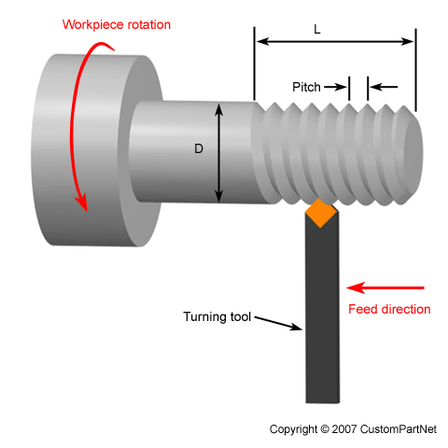

Some chip formations are unfavorable like ribbon chips, thread chips and long helical chips.

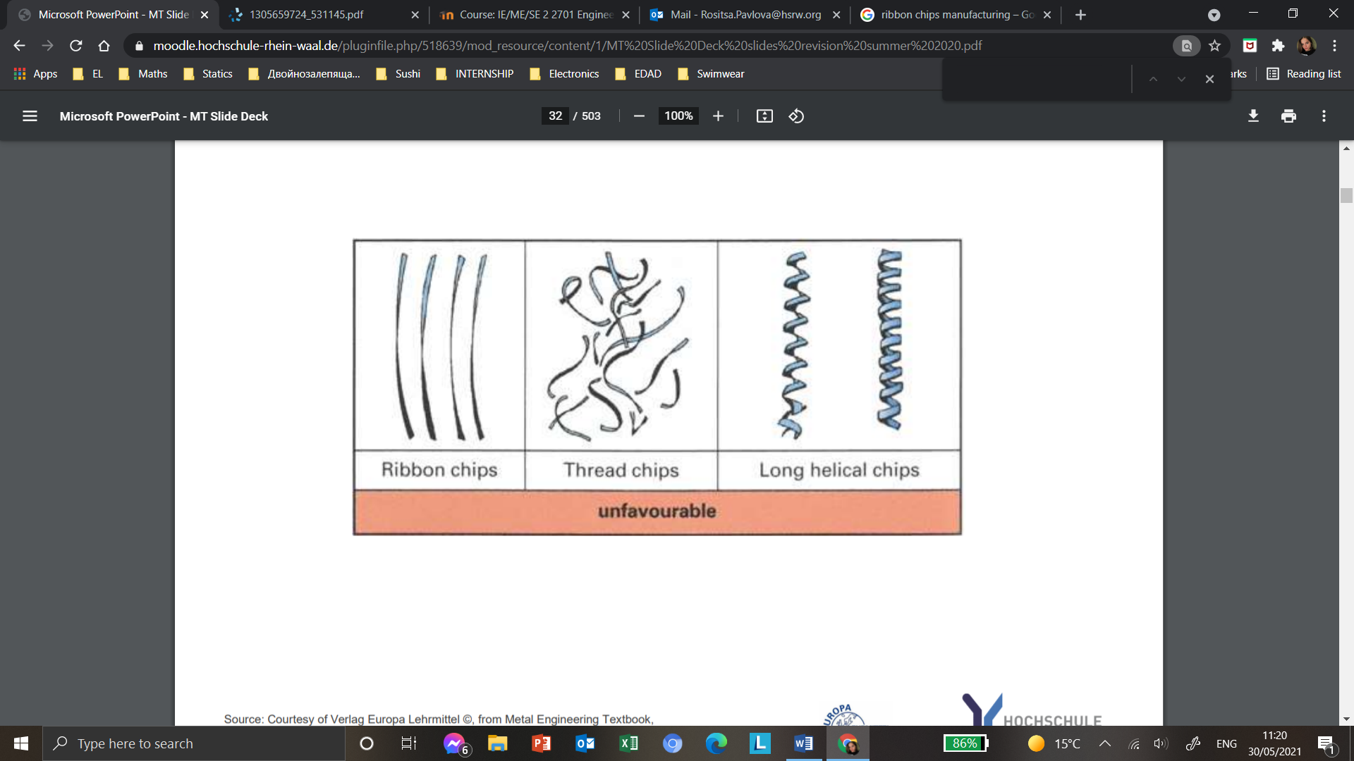

Others are favorable like short cylindrical helical chips, spiral chips and discontinuous ones.

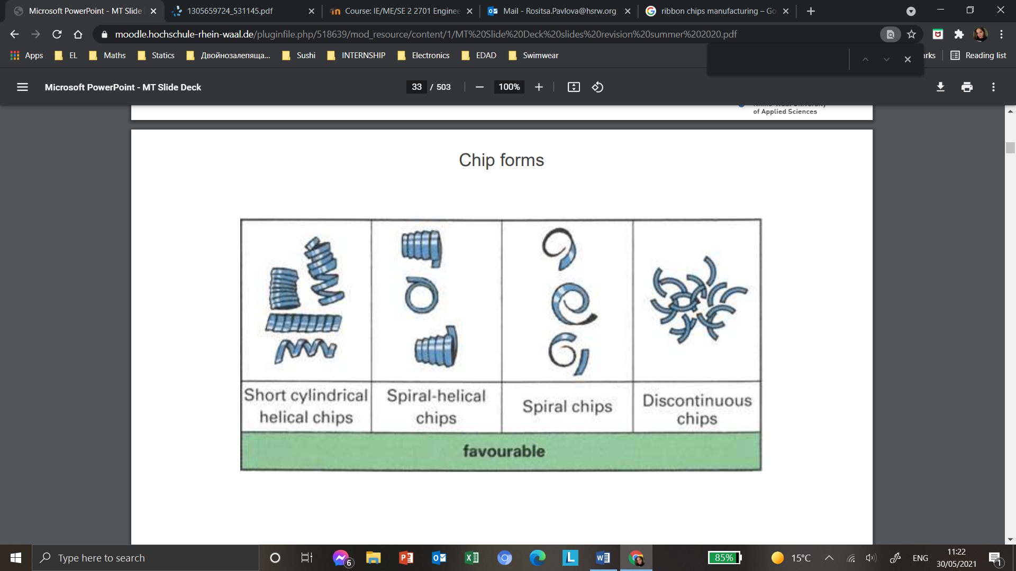

The cutting velocity has a big impact on the result of the cutting process.  
When the turning starts on the outer edge of the work piece it is the fastest. Then, as we get closer to the center the cutting speed decreases linearly to 0m/min.  
This means that at the beginning the chips are smooth and shiny, but as we get closer to the center the cutting speed decreases and so does the quality of the cut. Thus, the chips become rougher.

The feed in turning is the distance that the tool moves along the work piece while the work piece rotates once.  
The formula for manufacturing time is:  
  
 t = L/(f*n)

with L: length of the shaft in mm  
f: feed in mm/rotation  
n: spindle speed in rpm

A higher feed leads to a higher chip thickness and to a shorter manufacturing time. The surface is rougher when the feed is faster. This is called kinematic roughness.   
So, the selection of the feed should balance manufacturing time and surface quality. Finishing touches are done with a lower feed to smoothen surface.

The cutting depth is the reduction of the radius of the work piece or in facing operation- the reduction of the length of the work piece.  
The formula for the volume of removed material is:

Vr = (re^2-ri^2)*pi*l

with re: starting radius in mm  
ri: cut off radius in mm  
l: length of shaft in mm  
  
Higher cutting depth leads to higher chip width, higher material removal rate and also affects surface roughness- it makes it much more rough.  
A minimum and maximum cutting depth exists depending on cutting tool and work piece material.

There is such a thing as laser assisted turning, it uses two sources of energy, the laser is used as a heat source with a beam on the work piece, it is used for machining hard to wear materials such as ceramics and composites. It improves machinability and tool life is really high.  
This is an exotic tool that is rarely used.

* **Milling**

It is a machining process with a geometrically defined cutting edge.

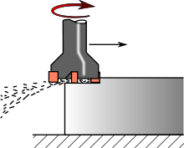

***Compared to turning***

In milling, the tool rotates and in turning it is the work piece that does, that is the main difference. So, here the feed velocity in mm/min depends on the tool, not to be confused with the feed per tooth in mm.  
The formula for computing the feed rate is:

Vf = n*fz*Nt

with fz: feed per blade in mm  
Nt: number of blades  
n: spindle speed in rpm  
  
If we increase the cutting depth, the chip thickness doesn’t change, but their width does. Additionally, the more we increase the depth, the less smooth is the final product.

Most milling tools have more than one blade/insert, this means there are multiple cutting edges.  
In turning, the tool cuts non-stop in the material, but in milling it is interrupted and started in every revolution of the tool.  
In milling, the tool geometries are more complex than in turning, so the chip thickness changes. A degree of freedom does not exist in turning concerning climb or conventional milling (direction of rotation of tool). Both methods have different finishes and are explained below.

To create the motion of the tool, you need a machine with degrees of freedom. There are machines with 3 axis (highest degree of freedom in turning) or 5 axis, the turning of the tool does not count as an axis/degree of freedom.  
In space, there is a maximum of 6 degrees of freedom, but in milling there are a maximum of 5 axis, because the work piece is solid and blocks it. In other words, the energy used to work the piece is the 6th degree of freedom.

With milling we can create a pocket with a corner radius. 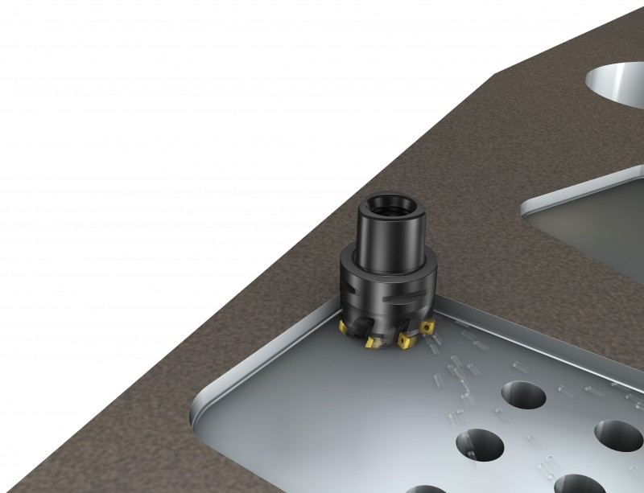

Here, we can speak of primary rotation (rotational movement of the tool), feed motion (translator movement of tool in radial direction), cutting speed, feed velocity and material removal rate.

***Types of milling***

Conventional milling means that while cutting the work piece from right to left, the cutter rotates anti-clockwise. It is used for rough operations; tool wear is really high due to the bad cutting conditions at the beginning of the cut. It is mostly used to cut bass, bronze and ferrous materials.  
In climb milling, while cutting from right to left, the cutter rotates clockwise. It is used for finishing operations, tool wear is low and is mostly used with aluminum.   
  
  
 There are fine (more blades) and coarse pitch (less blades means more chip room between blades, so more feed per blade which is an advantage, but also lower number of chips per tool rotation which is a disadvantage) milling cutters.  
  
 In hobbing, the tool and the work piece are rotating. The tool rotates at a higher speed. We have a coupled motion of tool and work piece rotation, plus additional feed rotation.  
It is used to create gears.   
There are solid body tools (same material as chips, the advantage is they are easier for designing and are very accurate, but the tool wear is fast) and tools with inserts (they are very cost efficient because you can change only the inserts, but very hard to manufacture).

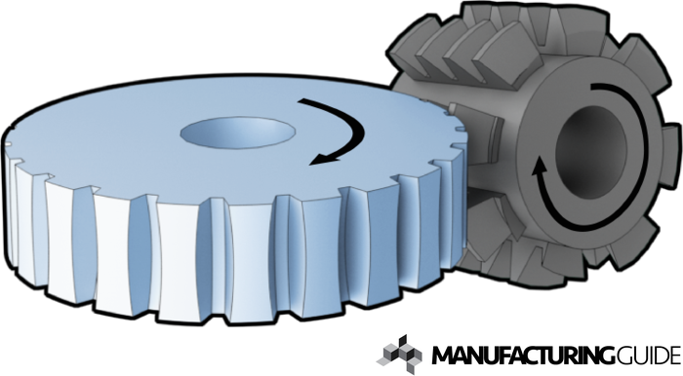

Helical milling is an alternative for drilling, especially for bigger holes. Here, holes of different diameters can be done with the same tool.   
It is a new high-quality hole-making process which offers many advantages such as better chip transportation and lower cutting forces and cutting temperature than conventional drilling.

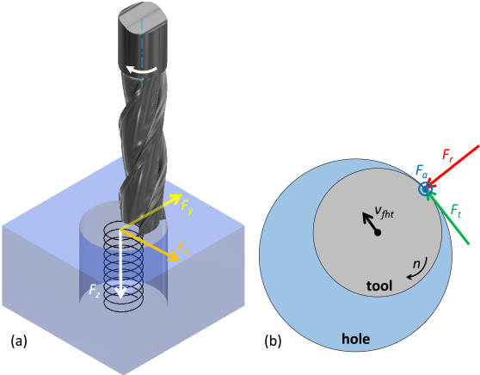

There are special milling operations such as:

1. Crankshaft milling- turn the inserts around when one side is worn.
2. Profile milling- tool has the shape of what you want to create and you just let it rotate or milling in 3,4 or 5 axis. The last one is harder to program, requires more steps, but it is easier to manufacture tool.

Drill, reaming or tapping tools can be used in a milling machine, but are not considered as milling processes.

To cool and lubricate the process, milling machines use cooling liquids. Some machines can even change the cutting tool alone as well as dispose of the chips.

In roughing, you want fast material removal, the surface quality is irrelevant.  
You will sacrifice the material removal rate and create a better surface finish in finishing.

**CAM:** Computer Aided Manufacturing is used to create virtually a work piece, then the file is sent to the machine in order to create it.

* **Drilling**

It is a major and common hole making process.   
The cutting occurs at the tip, the chips are disposed by flute.  
With gun drilling we can make long holes.

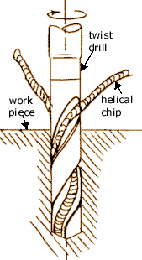

It deals with rotating tools and creates chips like reaming and tapping. Those three processes use a tool rotating around its centerline.

Drill tools have two cutting edges on the tip of the tool (spiral chip tip).

The formula for cutting velocity is:  
  
 Vc = ὠ*r = (pi*n*d)/1000  
with Vc in m/min  
r: radius of the work piece in mm  
n: spindle speed in min^-1  
d: diameter of the tool in mm

Before making a bigger hole with a drill bit, a smaller one is made with the center drill so the drilling tool is more precise. Liquid is sprayed during the drilling process to avoid overheating. The tool is lifted every few seconds to break the chip. This is done to avoid having bigger chips stuck to the spindle.  
Sometimes a countersinker is used to widen the initial hole.

Helical milling is an alternative for drilling, especially for bigger holes.

* **Reaming**

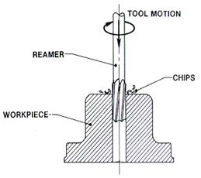

The difference with drilling tools is that reaming tools have cutting edges on the radius not only on the tip, they are long and thin, so they need a start hole like the drilling tools.  
Reaming tools are used to finish holes and create smoother surfaces.  
It is used at low velocity speed, so it takes more time and is more expensive.

* **Tapping**

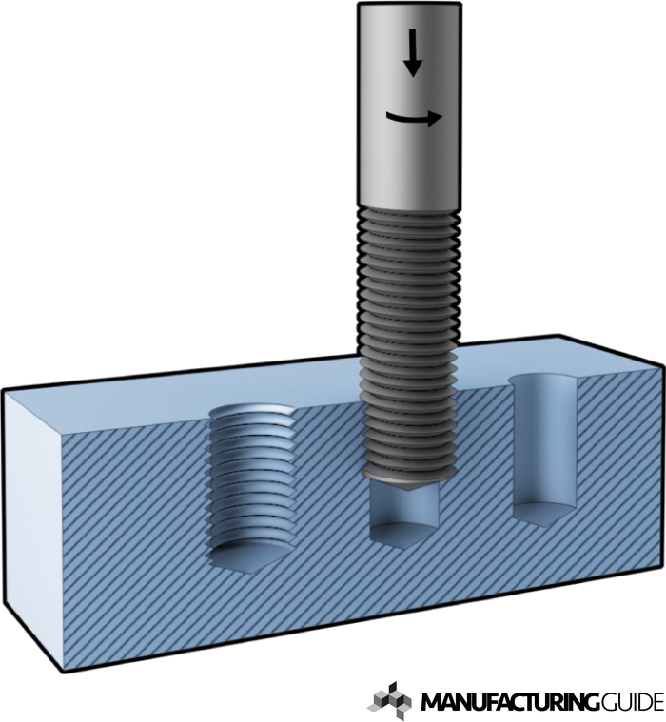

Those tools have chips on the sides and cut on the edges of those chips. When removed to cut chip, they have to be rotated backwards.   
A different tool is used for every given diameter. There is no helical motion, so a simple drilling machine is suitable.

Firstly, we have to drill a bone-hole and then cut the threads. An alternative to thread cutting is thread rolling, there is no deforming. It is a two-sided process, so the forces add up to 0, because they are applied on each side of the work piece which will not be deformed because it is between the two tools.

* **Broaching**

The tool makes a very simple motion, in most cases translator motion in one axis. It is with integrated feed, built into its geometry. They can be even 4-5m long.  
There are roughening and finishing teeth.

Broaching is a specialized manufacturing process praised for its speed and uniformity; it is a highly effective process when used for high volume production runs, but the tool is hard to produce and really expensive.

Broaching relies on a toothed tool called a broach. One of the most essential traits of a broach is the rise per tooth, which indicates the amount of material each tooth removes every pass. These teeth are then broken down into sections along the body of the tool: the roughing, semi-finishing and finishing sections.

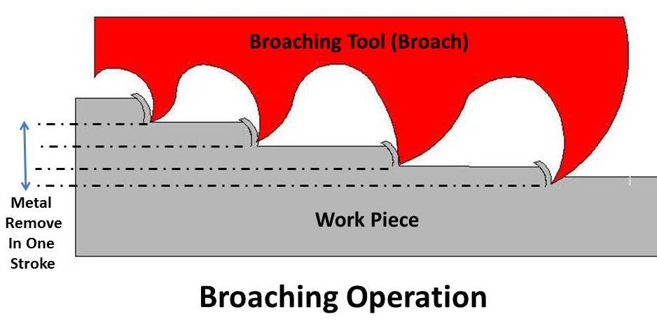

Sawing is based on the same principle of chip creation.

* **Skiving**

Here, the angle of the tool establishes the cutting velocity. It is an alternative to gear shaping.  
The tool is rotating and stroking simultaneously, so gear shaping takes a really high effort. Skiving does not require those strokes, it rotates.

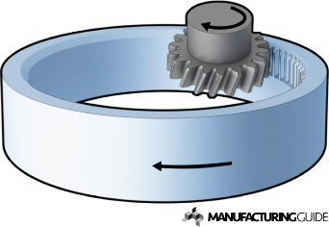

***Machining with geometrically undefined cutting edge***

* **Grinding**

It is common to have negative rake angles.   
Rake angle γ (gamma) is a parameter used in various cutting and machining processes, describing the angle of the cutting face relative to the work piece. A tool has a negative rake angle when the face of the cutting tool slopes away from the cutting edge at outer side.

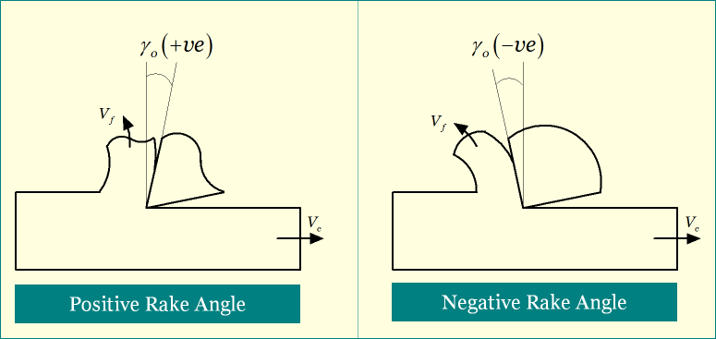

The 3 main components of a grinding wheel are the bond, the grain and the porosity (so the chips can go somewhere).

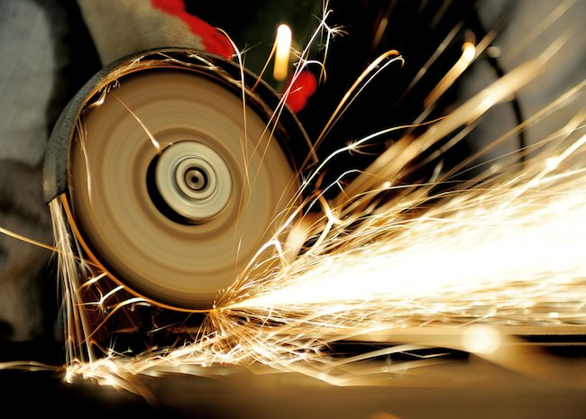

The motivations for grinding are:

* High geometrical accuracy needed without feed marks/kinematic roughness.
* Low machinability of work piece material (how nice the work piece can be cut- forces, surface finish, tool life).
* High surface finish required.

The chips are small because there are many cutting edges with negative rate angles.

The tool or the work piece can be the one moving, it depends on how the machine is setup.

Centerless grinding is used for high volume production of simple cylindrical pieces.

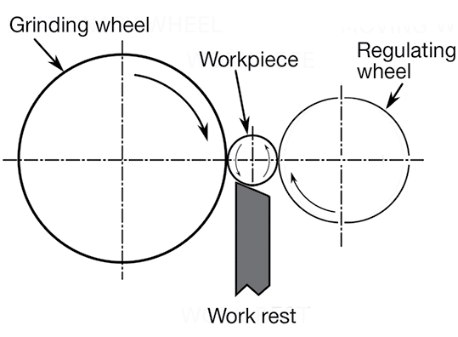

Form grinding allows to create everything at the same time, but a lot of force is required to use the special tool, but the process is much safer.  
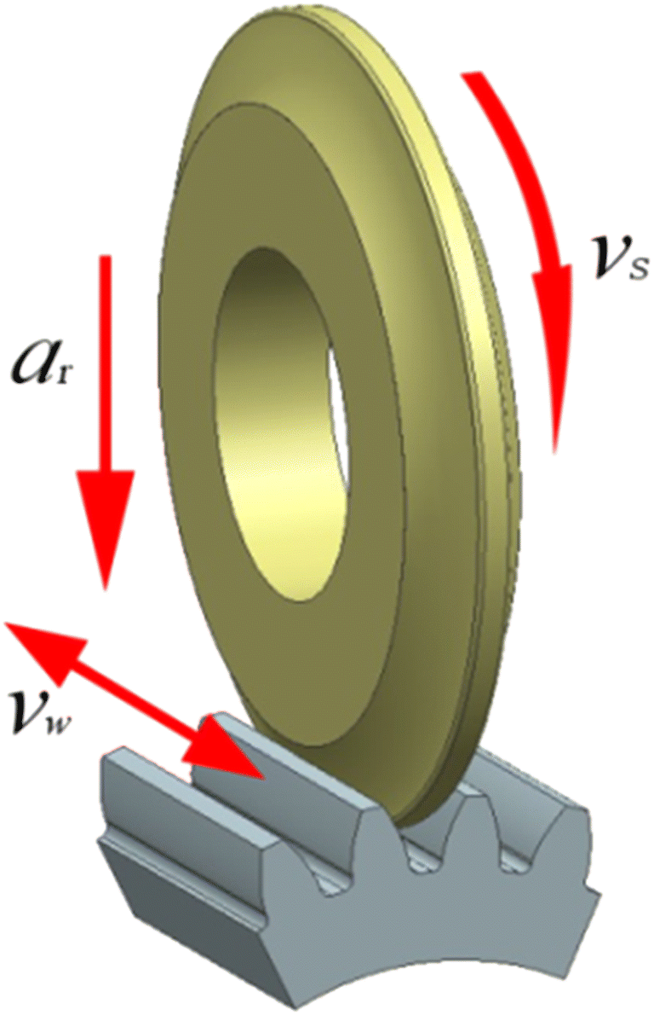

The purposes of dressing the grinding wheel are to reshape it, change the geometry of the tool and resharpen it.

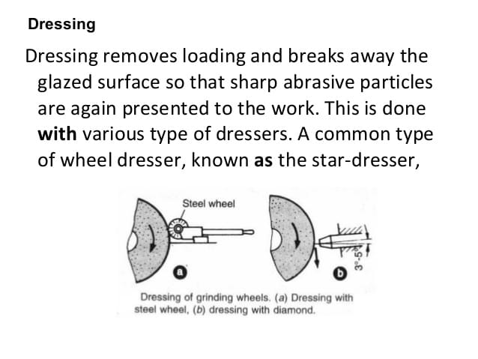

A grinding burn is a collateral damage (unwilling 2nd effect). They are invisible (that is why they are dangerous), but can be made visible. It is an unwanted heat influence from the grinding.  
   
The disadvantages of grinding compared to milling are that the material removal rate is much lower and requires higher precision as to not damage the work piece.

* **Honing**

Honing means we have a low cutting speed.

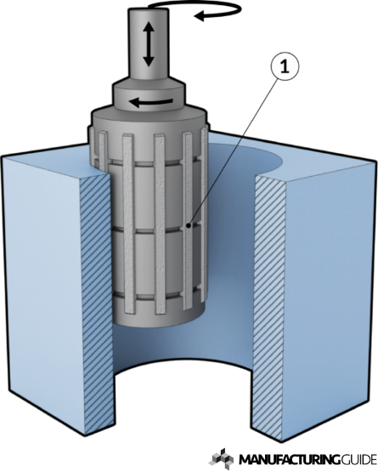

We use it to work internal surfaces and create holes (automobile cylinders).

* **Lapping**

Two pieces are pressed against each other with loose powder between them. The little particles (liquid = oil + abrasive) will start removing material.

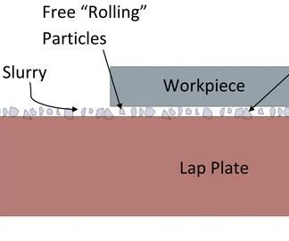

The pinion applies pressure on the gear and both remove material from one another. They are married (created together) and have to remain paired.

* **Polishing**

Polishing is used for shiny, smooth surfaces (injection, tool molding, optical lenses), not the same as car waxing, because you are actually removing small quantities of material.

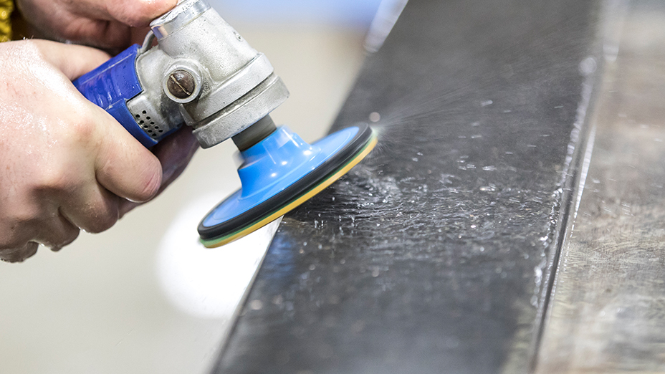

**Cutting materials and cutting fluid**

It is harder than work piece material. High speed steel (HSS), diamond, ceramics, cemented carbide are used.

Materials are selected depending on their hardness (resistance against penetration/wear, dali se gune) and toughness (resistance against breakage with dynamic loads, it is the opposite of brittleness, gune se kato go natisnesh, no ne se chupi).

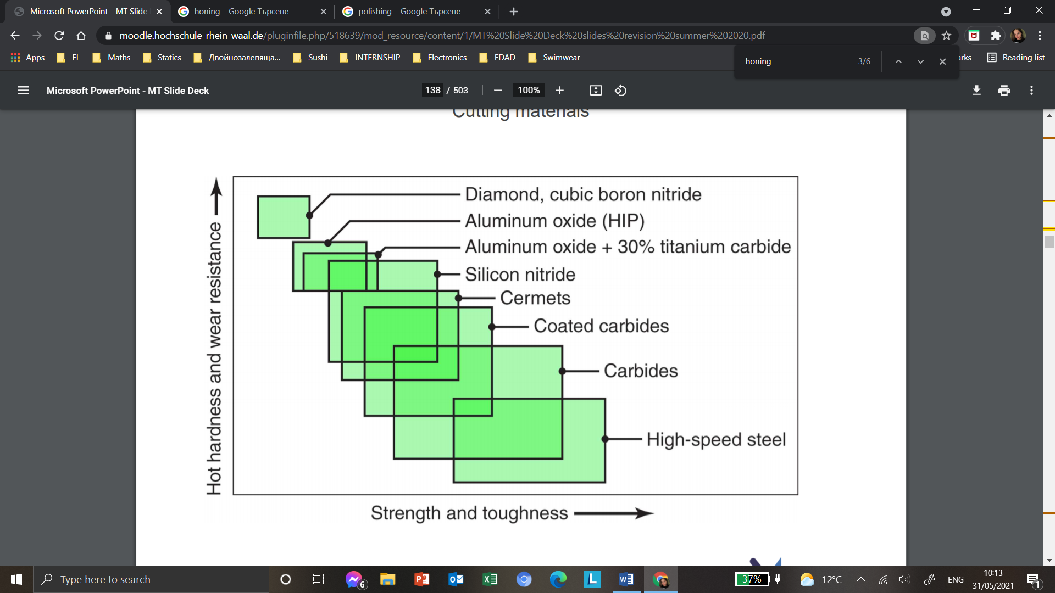

Ceramics fall in the center of the graph and can be called the ideal tool.

***Tool wear and tool life***

With loss of tool volume, the cutting edge gets displaced (shift of real edge position) which leads to geometrical error (loss in accuracy).

There are different wear types:

* Chipping and microchipping- little pieces break off.
* Adhesion- material sticks to tool.
* Abrasion- tool loses material gradually.
* Surface fatigue- chemical reaction.
* Breakage- catastrophic failure.

But keep in my mind that you have to detect the right point of time to replace the tool- early change is waste. So, predictable tool life is desired. The longer the tool life, the lower the price is per piece.  
  
Tool life depends on cutting speed, feed, depth of cut, tool material and geometry, tool coating, work piece material (machinability), inclination angle λ…

Tool wear is the amount of wear you have in total (length, width, …), whereas tool wear rate is the speed at which the tool decreases.

Here is a tool wear chart.

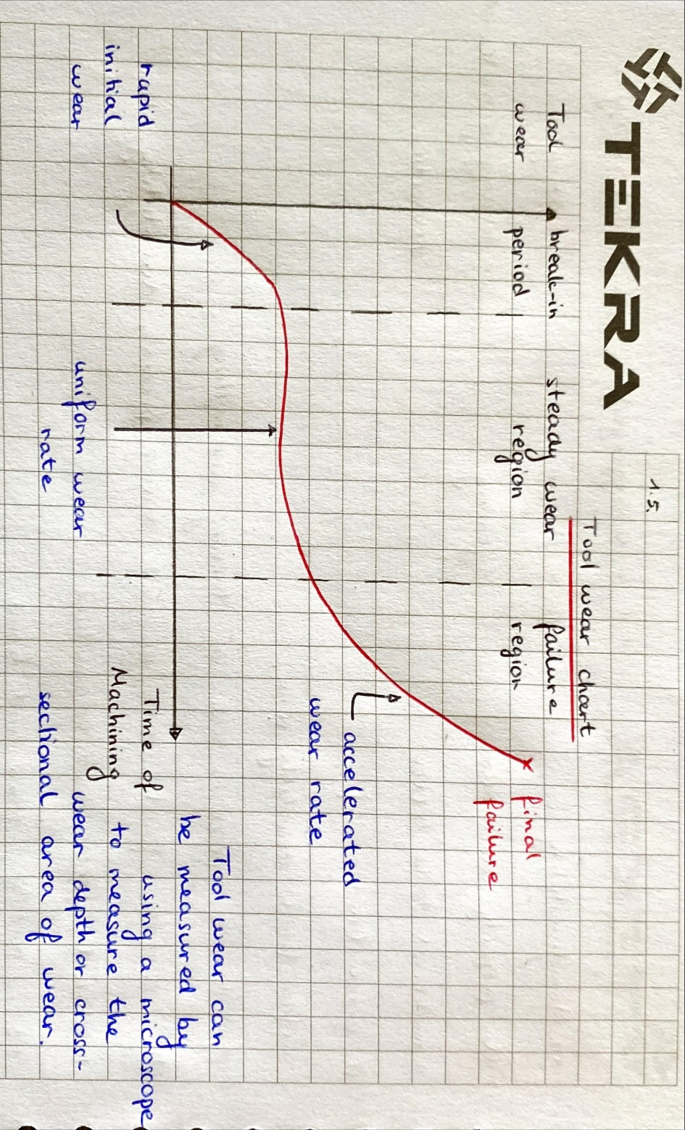

A cutting fluid is a fluid with controlled temperature. It is poured on the tool to cool it, the work piece and the machine structure. It also removes chips, rinses them, lubricates, reduces wear, reduces friction and, thus, increases precision. It can also prevent corrosion.

There are different types like oil and an emulsion (oil + water).

**Special types of machining**

* **EDM- Electrical discharge machining**

Material removal happens very slowly in contrary of milling and grinding. You use such a process for smooth surface finish, small pieces, sharp edges (tool and die making), square holes (without radius in corner), etc.

Material with very low machinability can be machined like cemented carbide, ceramics, etc.

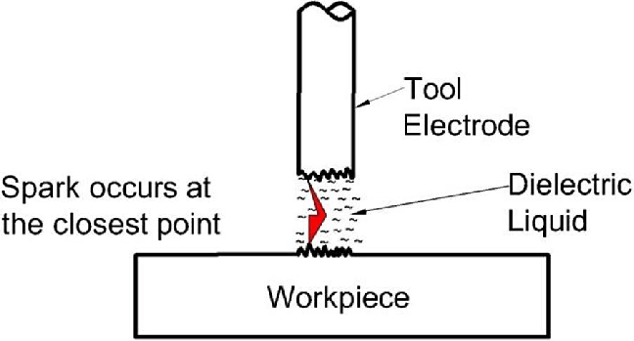

There is no contact between tool and work piece, the gap is filled with dielectric fluid used to avoid oxidation, rinse, cool work piece and insulate. Material is removed by rapidly recurring current discharges.   
The tool can be a wire which has to be replaced very frequently because it’s very thin.  
  
The disadvantages of EDM are:

* Compared to milling, it is really slow (low machining rate).
* Etc., because it depends with what you compare.
* **ECM- Electro-Chemical Machining**

The work piece is dissolved into electrolyte fluid; no sparks are seen here. It is used to machine super hard alloys.

There are no thermal stresses, no mechanical stresses and no tool wear because of the cool liquid. Here, the fluid is conductive and not insulating like in EDM.

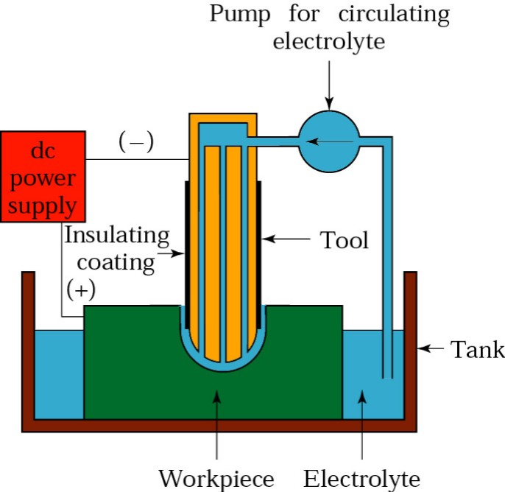

* **Laser cutting**

There is no physical contact between work piece and tool, there is no tool in the classical sense- it is a laser beam. It is happening in a protective gas nozzle, it protects against oxidation and blows out removed material.

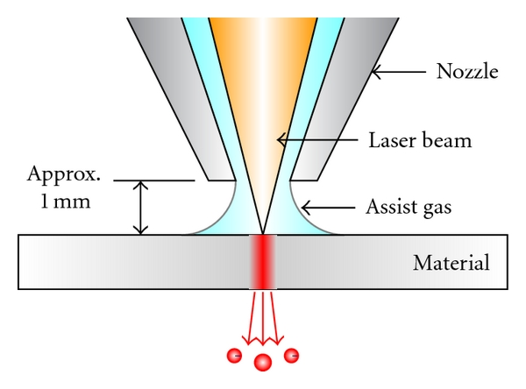

Water jet cutting exists where water with very high pressure allows to work on the work piece.  
  
 **Deforming**

Here, the volume of the work piece remains constant.

***Deforming fundamentals***

**Elastic and plastic deformation**

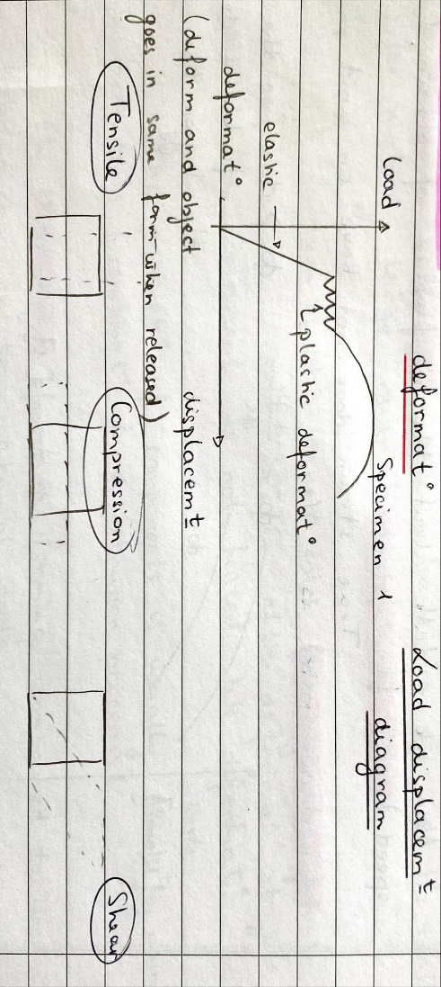

**Flow stress**

It is the stress level in work piece that is required to initiate and sustain plastic deformation. It depends on temperature, shear strain and true strain of the work piece.

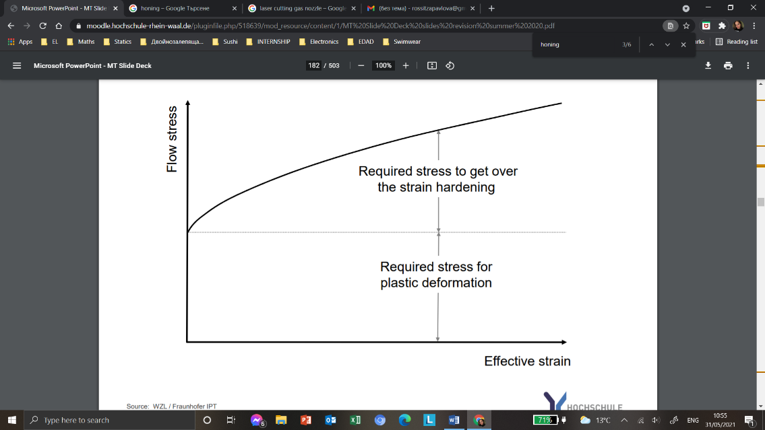

**True strain**

The formula for true strain is:  
 Ф = ln(H1/H0)

with H1: new height  
H0: old height

**Fractures**

They happen when you pass the critical strain. The fracture shape depends on the present stress condition. There are fractures in crossing and longitudinal direction.

**Strain hardening**

It can cause critical deformation/fracture, tool overload or machine overload. It can be reduced by recrystallization.

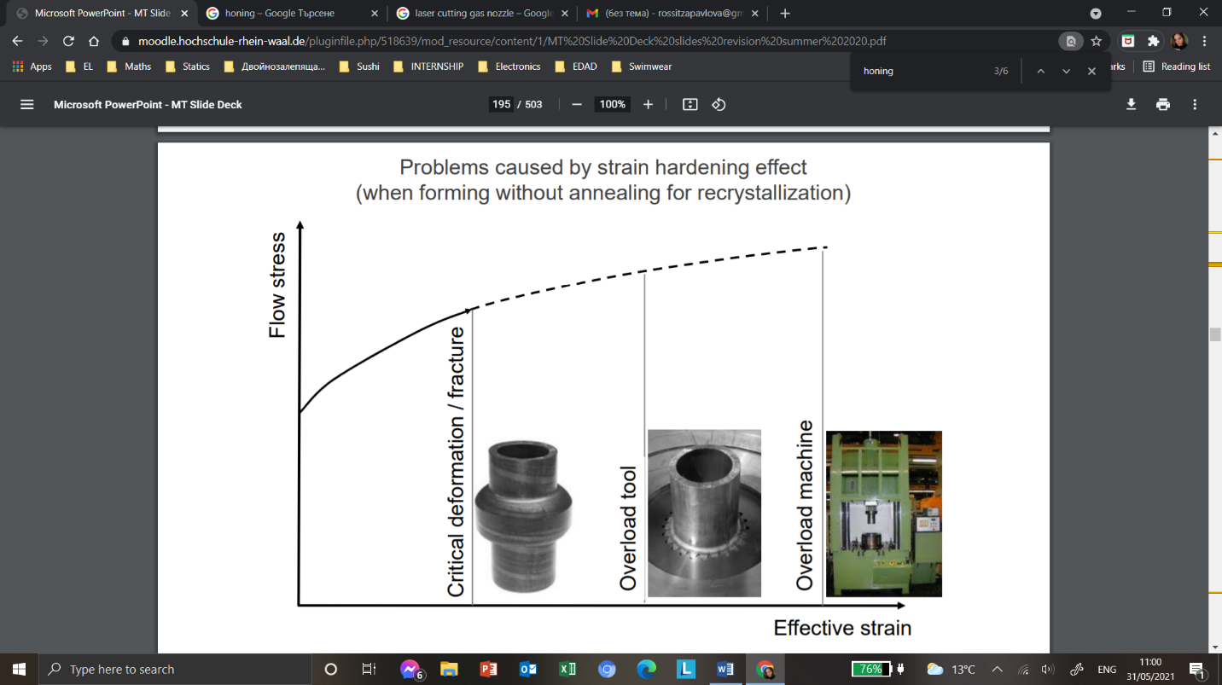

**Recrystallization**

Recrystallization is a process by which deformed grains are replaced by a new set of non-deformed grains that nucleate and grow until the original grains have been entirely consumed.  
  
Recrystallization is usually accompanied by a reduction in the strength and hardness of a material and a simultaneous increase in the ductility (when a solid material stretches under tensile strain, this way a material may be stretched into a wire). Thus, the process may be introduced as a deliberate step in metals processing or may be an undesirable byproduct of another processing step.

Or, in other words, the recrystallization temperature is the temperature at which the metal becomes more workable and ductile.

In cold forming, we recrystallize the work piece to reduce the flow stress in it and, thus, to be able to deform the work piece even more.

**Influence of strain (deforming speed) on flow stress**

True strain does not have an unit, the unit of strain rate is 1/s.  
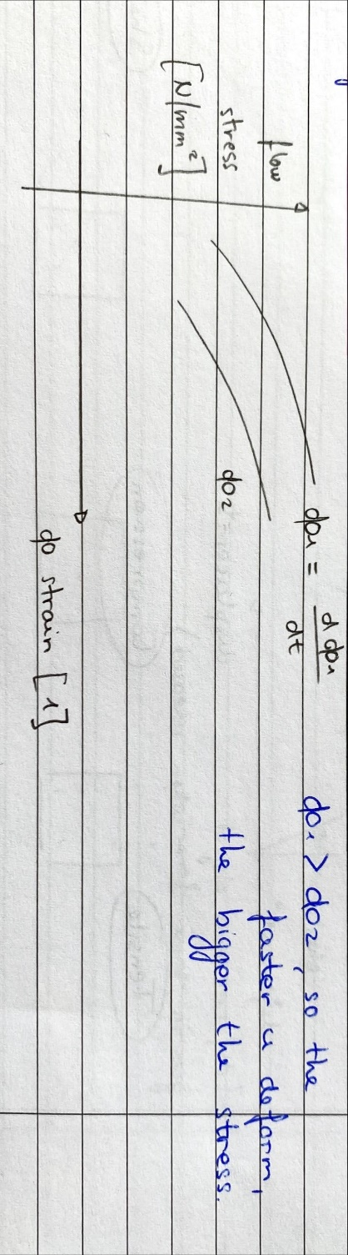

The flow stress is the stress that must be applied to cause a material to deform at a constant strain rate in its plastic range. Because most materials work harden under these conditions the flow stress is a function of the degree of plastic strain.

**Tribology**

The science (engineering discipline) of friction, lubrication and wear.

***Types of deforming***

* **Extrusion**

Bulk forming process in which material is made to flow using high pressure.  
Extrusion is a process used to create objects of a fixed cross-sectional profile. A material is pushed through a die of the desired cross-section.  
 The extrusionprocess can be done with the material hot or cold. Commonly extruded materials include metals, polymers, ceramics, concrete, modelling clay, etc.

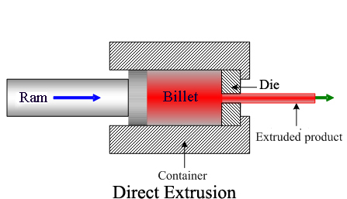

* **Bending**

We talk about plastic deformation (when released they don’t go back to old shape). We have tensile stress on outer part of work piece and compressive on the inside.

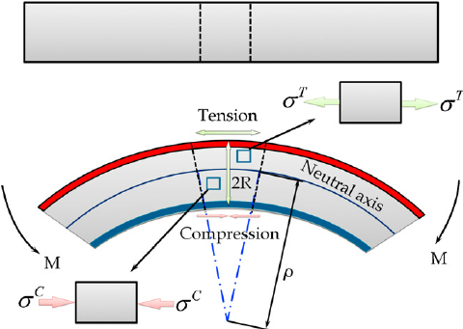

A spring back effect might happen. This means residual stress of component leads to spring back. It can be anticipated and compensated.   
  
 Bending can actually lead to really sophisticated forms.

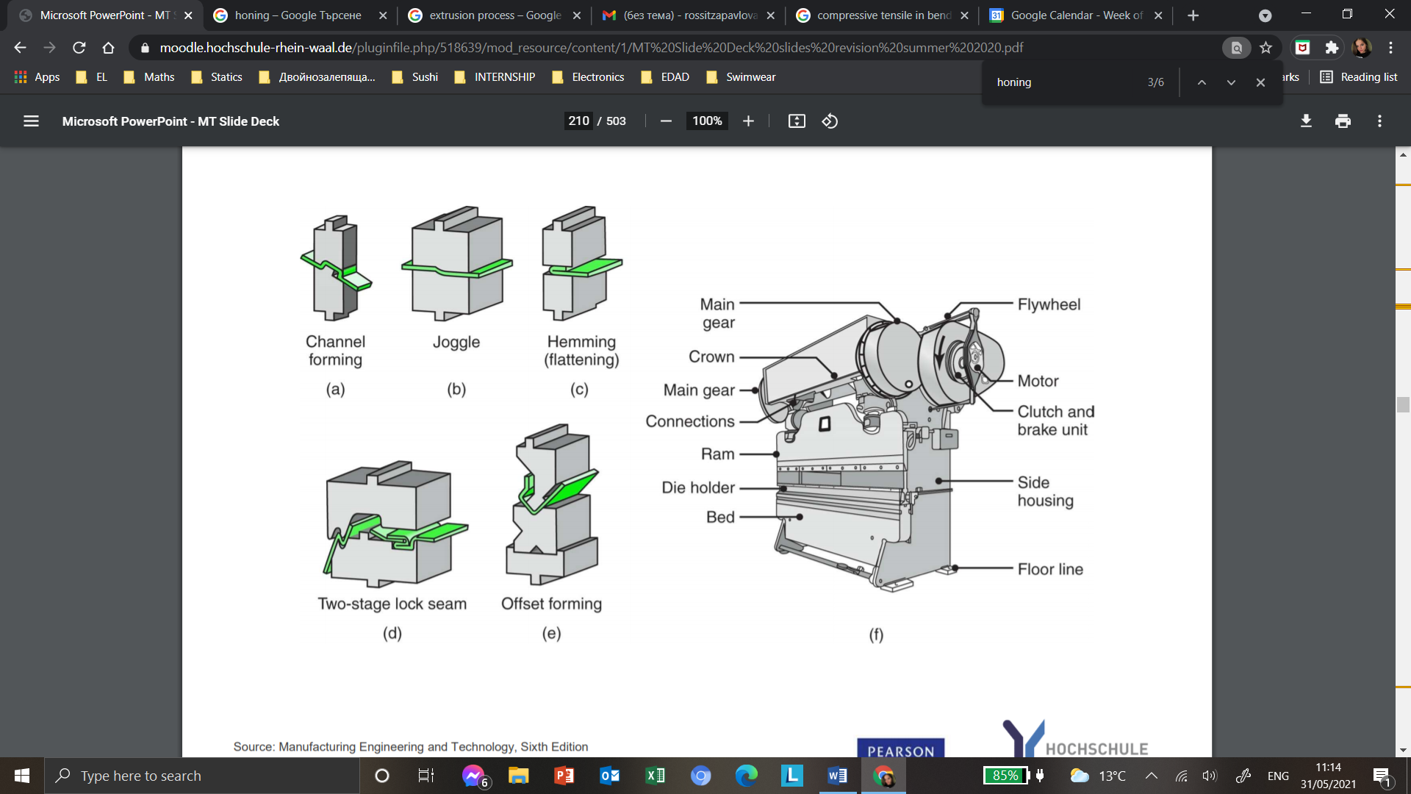  
We can roll to from a shape. For example, with a three-roll bending machine.

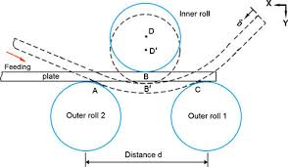

* **Bulk deforming**

It is the opposite of sheet metal forming. It can be done warm and cold (high flow stresses, low achievable strain- classic steels).

Cold forming is used to make smaller deformation compared to hot extrusion. To do so, you have to insert the work piece, compress it, extrude it and eject it.  
Some typical cold formed components are gear shafts, toothed components, ball pins, etc.

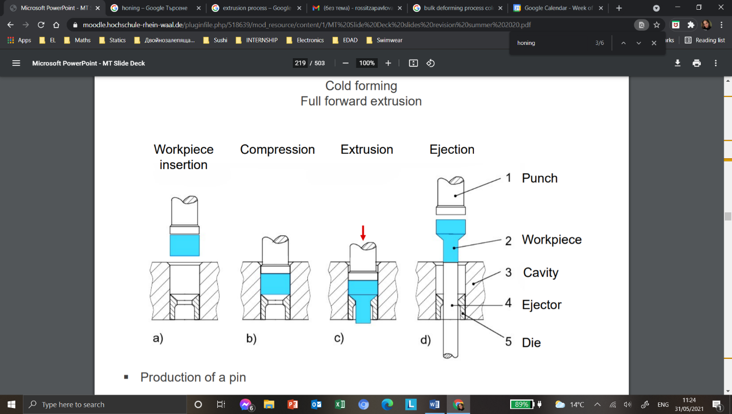The production of components is usually composed of different extrusion processes.

The process is really fast once you have your die, so it’s really used for making large quantities of work pieces fast (that it’s why it’s called bulk deforming).

Even if it is called cold forming, the components can reach up to 300 degrees Celsius after deformation, it just means the component is not heated before deformation.

The advantages of cold forming compared to warm forming are:

* Low material costs
* Low influence of forming velocity
* No energy for heating required
* High surface quality
* Increasing strength of component

The disadvantages are:

* High forces required (high flow stress)
* Limited plastic strain
* Lubrication required

Now let us do a case study comparing the creation of shaft by using turning or cold forming.

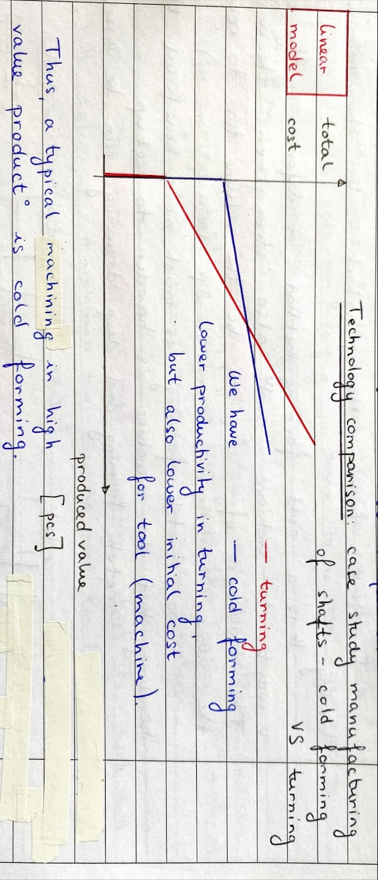

***Compared to cold forming***

Now, about warm forming, it is for larger work pieces (quantification of deformation in 3D). The equivalent stress (local value for one spot in the work piece) is a number which breaks down a multiaxial condition of stress into a one-dimensional number. It is bigger for warm forming than for cold forming.  
There is additional resource consumption. Also, the finish is worse because of deformation due to temperature.   
It is used for a high degree of deformation because with temperature you can deform more.

***Ironing***

It is a bulk deforming operation because there is a significant change of wall thickness (severe deformation). It is applied for a defined reduction of the wall thickness of a work piece like a Coca-Cola can.

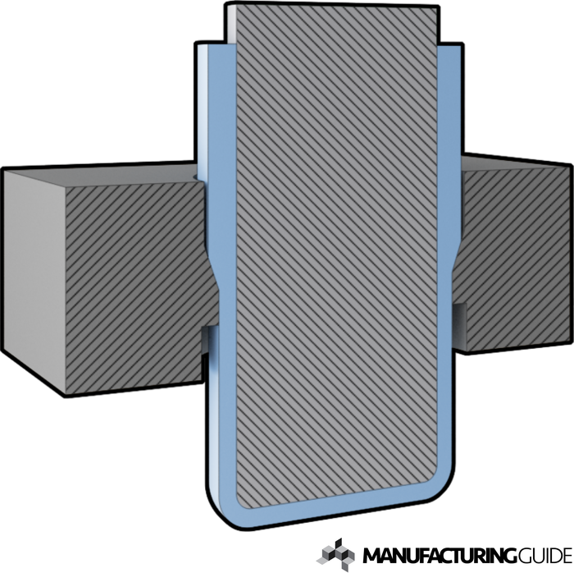

* **Sheet metal forming**

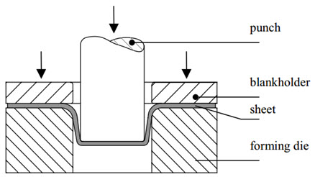

It is the opposite of bulk deforming. There are smaller deformations, lower forces are used, lower strain hardening and no or low change of wall thickness.

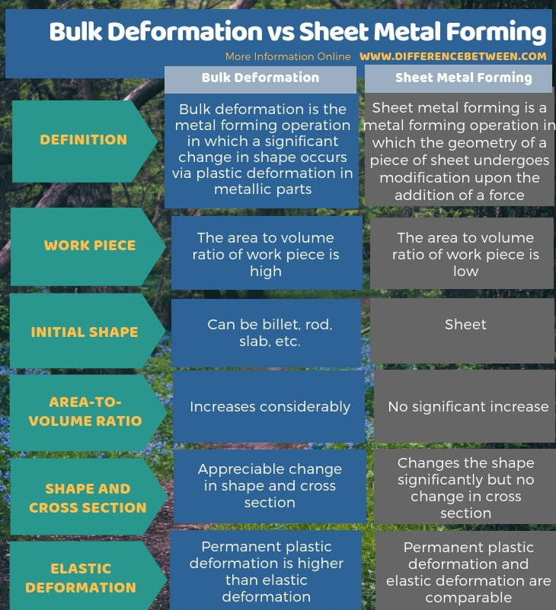

A sub-variant is sheet metal forming with tailored blanks. They are put together from different pieces of sheet metal.  
This allows low waste production with precision, but big resource consumption. So, it’s useful for large production.

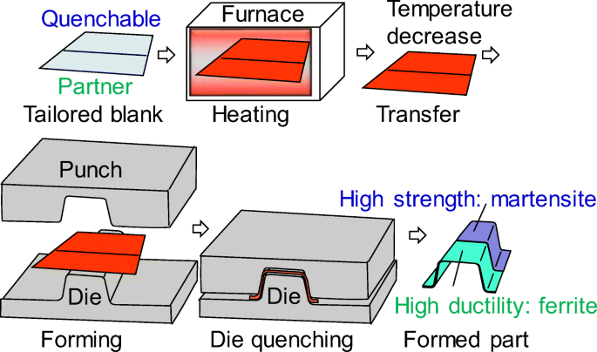

* **Stretch forming**

It allows low tool and machine costs compared to the size of the work piece being produced.   
There are many techniques causing different amount of waste material.   
In stretch forming, the spring back is less than in bending.   
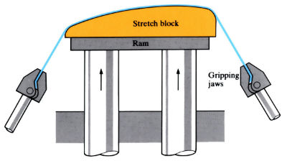  
  
It is a cold forming method, it deforms in the shape you want to achieve and also strengthens the work piece (positive side effect).   
The thickness (not the same along the work piece- local phenomenon) of the work piece decreases because the volume has to remain the same.   
  
 So stretch forming is much more beneficial than bending, but the machine is harder to set up.

Stretch forming and deep drawing can be used together.  
In deep drawing, the thickness doesn’t change.

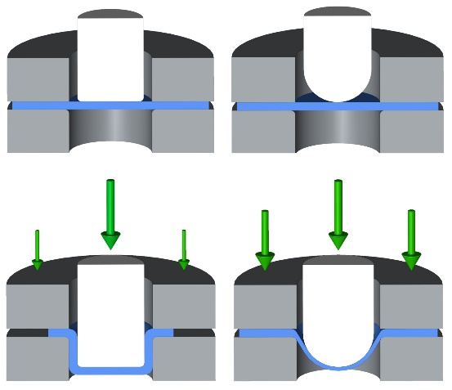

* **Forging**

Here, the deformation is bigger than in sheet or bulk forming.  
Forging without burr means we have to position the work piece perfectly. Low forming forces are required and there is no material loss.

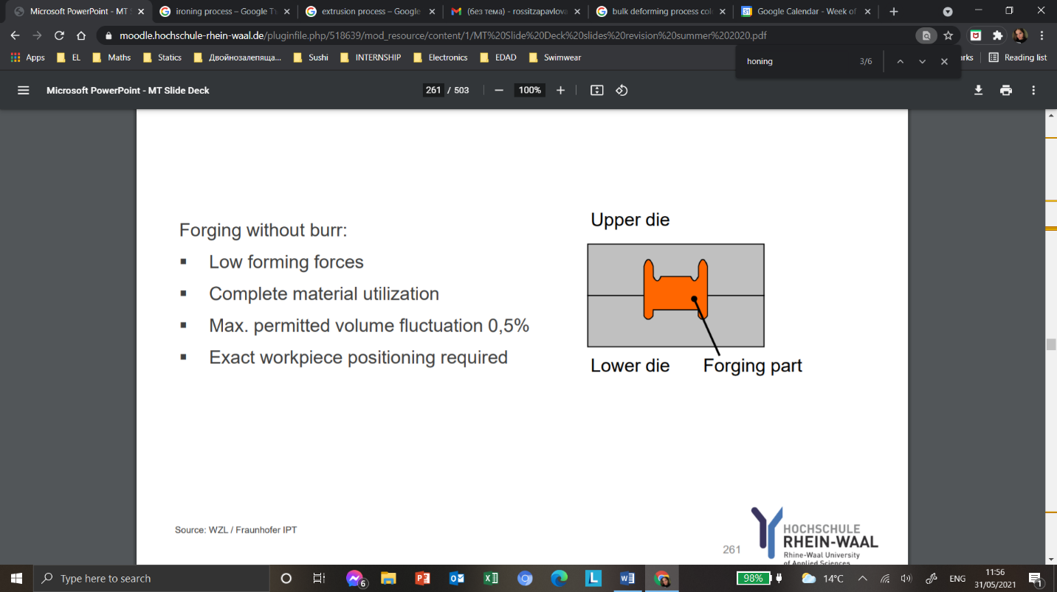

As for forging with a burr, there are less standards on work piece volume fluctuation so you can change position slightly. But an extra step is required to remove the burr with, typically, punching or piercing,  
Large quantities are made quickly with this process.

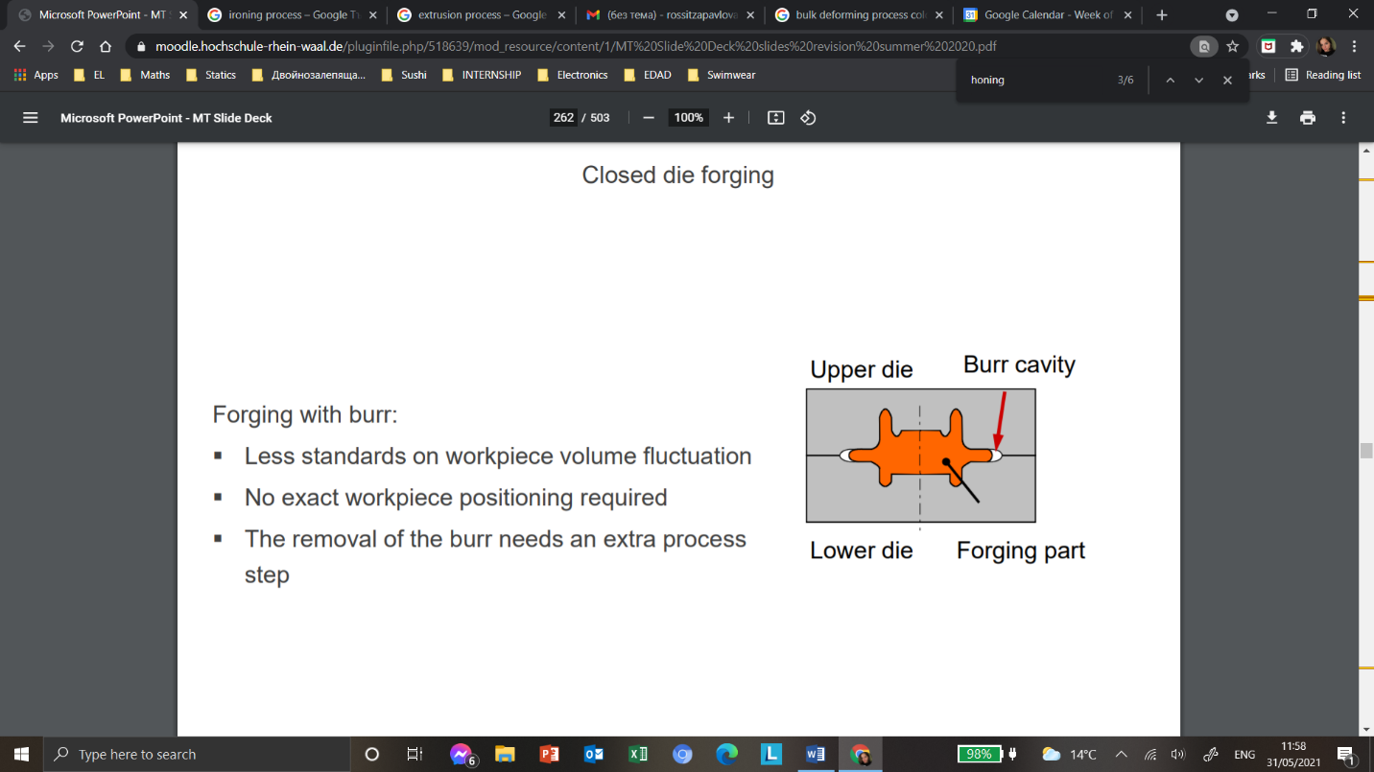

There are different heating methods in forging like heating in a furnace by oil or electricity or by induction (really quick).

Simple tool geometries are used for open die forging processes. No special die needs to be created for a specific work piece. You only have to create the right motion to create sophisticated geometries.

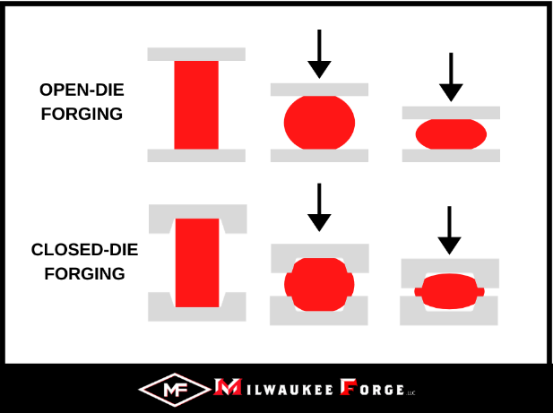   
  
 Scales might be formed due to high temperature and can be then removed.

***Compared to cold forming***

Forging uses less effort and can deform more, but we need more energy input for heating, the material costs for tools are higher and there are more dimension faults by shrinkage.

**Material of tools and lubricants**

The material of the tool is mostly steel for sheet and bulk deforming. A combined tool can be used too (steel tool with ceramic insert in a single section).  
  
 In deforming, lubricants prevent the die and work piece from coming into direct contact with one another, in order to make it impossible for the material to be transferred from die to work piece. It also reduces the friction between the surface gliding against one another.

In deforming, the main reason for tool change is the abrasion on edges and cracks in cavitation.  
Tool making is very costly, so we repair and use the die multiple times. To do so we remove the material to have a nice smooth surface (by mill/grind/EDM). The loss of material can be compensated by reprogramming the tool.   
  
**FEM:** Finite Element Method is used in deforming, it is used to determine strains, tool stress and right split of subsequent processes. This is done so we don’t discover by trial and error which tool material and strain forces to use, this way you detect the problem before it occurs which is cheaper.

**Shaping**

Those processes allow you to generate something with defined geometry from something that is shapeless.  
The most widely used technologies are casting (molding), powder pressing and additive manufacturing.

* **Casting**

Complicated geometries can be realized, there is a high degree of design freedom. Also a high material utilization and 100% recyclability.

There are three principle ways to do it:

* Casting with a lost mold with reusable (wood) or non-reusable pattern (Styrofoam)
* Casting with reusable mold

***Sand casting***

To make a mold using sand casting which is a casting with lost mold and reusable pattern, we do it the following way:  
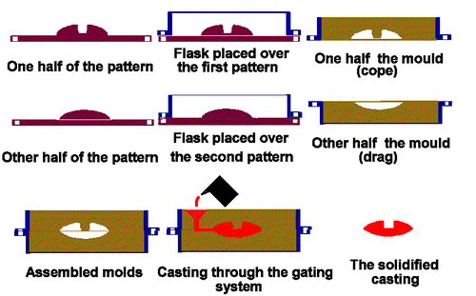  
Do not forget that the sand gets hard after being poured on the pattern because it is a combination of glue and sand. Sand can also be reused, not as a pattern but as a material (not expensive anyways).  
We can observe that the mold is made from two pieces.   
This process can be automated and done very quickly. After inspection, you can do additional machining.  
  
 You should always have draft angles to be able to remove the pattern from the mold.  
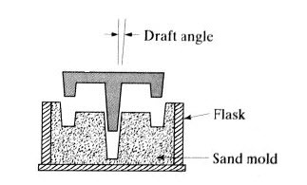

There is sand casting with lost pattern (Styrofoam). It is really cheap and easy to create compared to wooden patterns, but can be used only once.  
You pour the molten metal while the Styrofoam is still inside and it’ll burn and replace it.  
It allows a higher degree of precision.

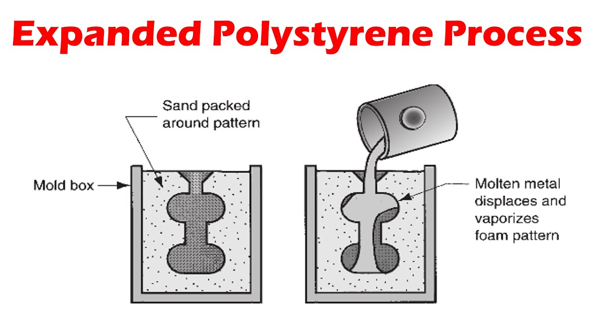  
**The molten metals are always poured from bottom to top in all of those processes.**

***Injection molding***

Here, we cast with a reusable mold.   
It is applicable for metals, glass, elastomers, etc. It can be used to make Legos (thigh tolerances, so high quality injection mold), bottle caps, plastic products, etc.

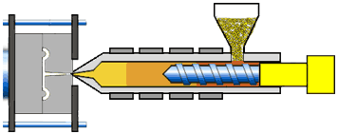

***Centrifugal casting***

It uses centrifugal forces to press liquids to the side of cylinder and solidifies it. You can create a pipe this way.

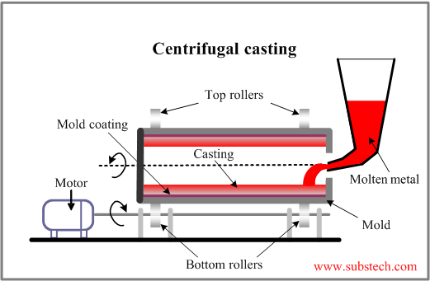

***Continuous casting***

It can create something with infinite length if it doesn’t run out of liquid.

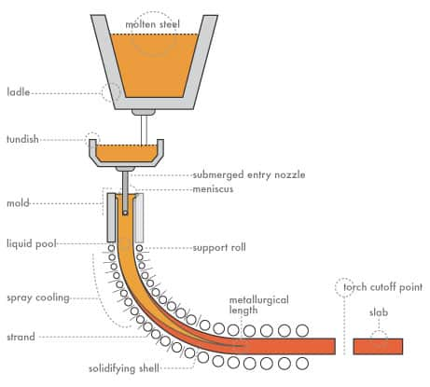

***Investment casting (Precision casting)***

It is a different form of sand casting, used for high precision.  
Pattern is made of was and mounted to a cluster, it is dipped into glue that covers it. Then, the wax is melted away and the glue remains- the mold is ready.

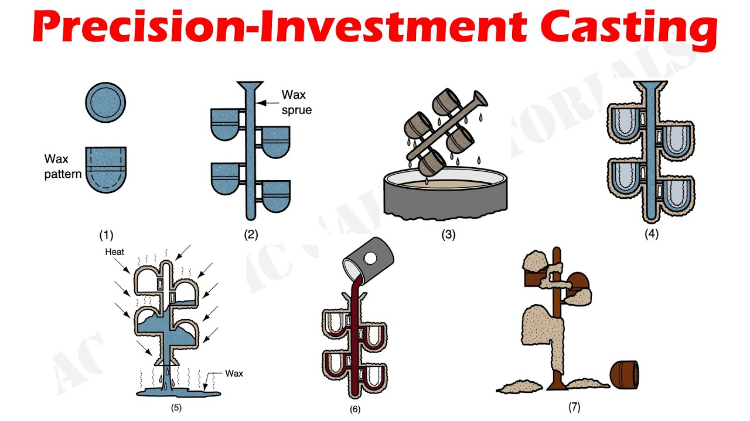

***Process review of Powder Pressing***

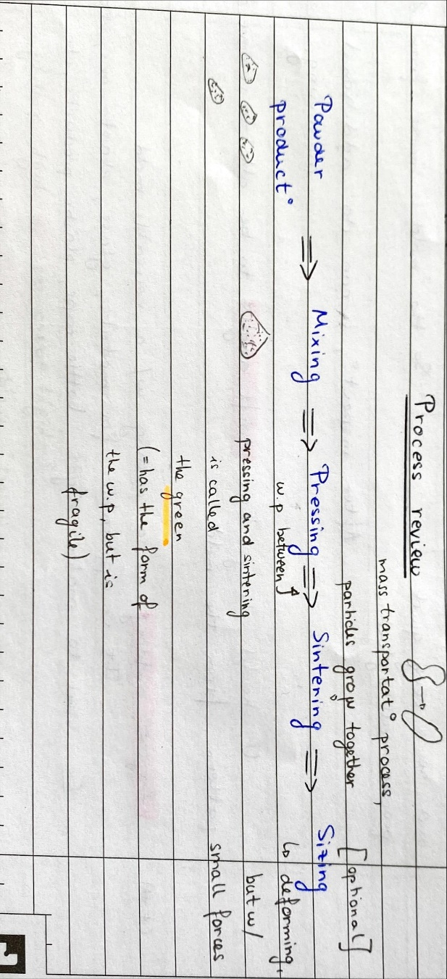

To choose the powder, you have to think about the particle size, their distribution, etc. It has to be chosen very carefully.

* **Sintering**

There is a solid phase and liquid phase sintering.  
It is the process of compacting and forming a solid material by heat or pressure without melting it to the point of liquefaction.   
Bonding that occurs during sintering greatly strengthens the part.

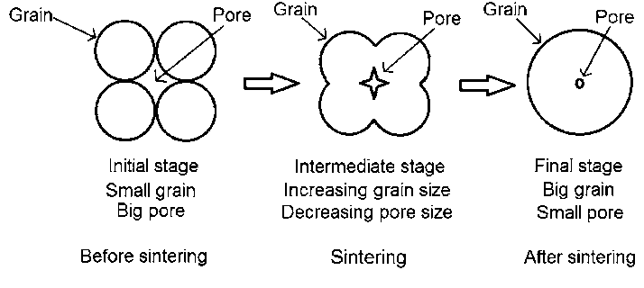

It is done in a furnace.  
  
***Compared to deforming***

A sintered work piece has remaining porosity, there is no strengthening effect. This is a disadvantage. But we used it nevertheless because it is cheaper than deforming because of low forces being used.

* ***Additive manufacturing***

Known as 3D printing, there is no need of a tool or a die just a geometry generated through a machine program.

Unlike most conventional manufacturing techniques, additive manufacturing forms objects by building them up, rather than removing it.  
  
 The advantages are that there is a high degree of geometric freedom, low maintenance cost and non-wearing operations can be done.  
It can be used for spare parts, prototypes, tool making, etc.  
It can be used for lightweight structures like in the aerospace industry, medical implants, jewelry, etc.  
  
 The disadvantages are the slow manufacturing process, not suitable for mass production, material selection is limited, high surface roughness in raw state, etc.  
  
 The used materials are plastic, raisin, ceramics, etc.

***Types of additive manufacturing***

In additive manufacturing, the most common used technology is selective laser sintering (plastic, glass powder, etc.)/melting (titanium, special alloys, etc.) (SLS/SLM). A UV laser is being used to cure a powdered material. And so, layer by layer, this cured powder creates the work piece. When on layer of powder is applied, you first clean the work piece after applying the next one.

Remember in sintering we do not actually melt the work piece, we just heat it to strengthen it and press it together- SLS.  
When we actually melt the work piece we are talking about melting (duh)- SLM.

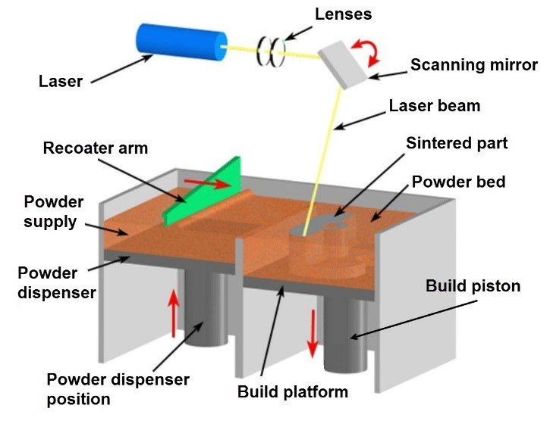

We can then speak of Stereolitography (SLM). Here, the process is the same as in laser sintering/melting, but the starting material is not powder, but a resin. So, layer by layer, you build something solid from something that was liquid before.

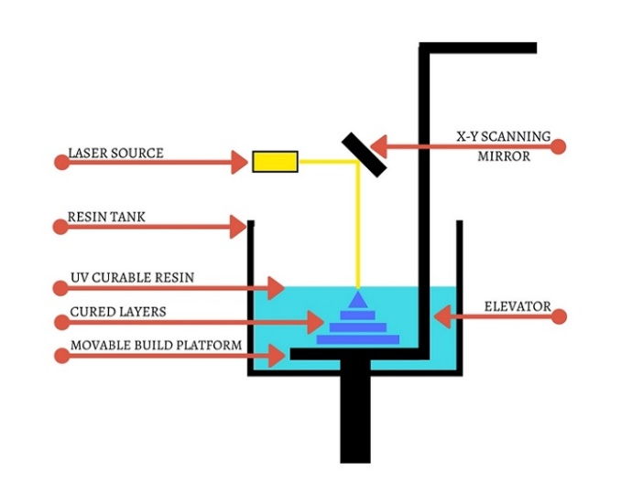

The cheapest method by far is fused layer modelling (FLM). It consists of a wire being melted in a nozzle, which then drops droplets on the work piece that harden immediately. This is a plastic printer.   
It is almost like welding (spoqvane). It is used for small parts that do not have to withstand significant forces.

3D printing is the application of a liquid bonding agent onto thin layers of powder (resin based). You spray the liquid on the powder and the particles are glued together, when you remove the loose powder you get the somewhat wanted shape. You can use other processes to harden the work piece and have a smoother surface finish.

Layer laminated manufacturing (LLM) is a stack of little shapes that create a figure like in architecture. A laser cuts out the different shapes.

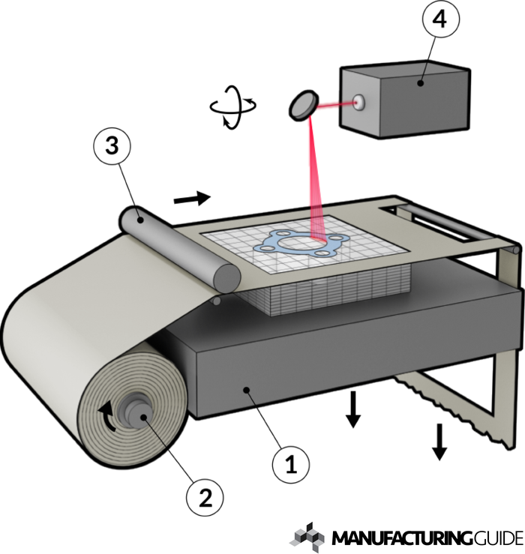

**JOINING**

Joining consists of putting pieces together (countable, known number, otherwise it is joining) that can handle a degree of forces like a frame of a bicycle.  
We can distinguish between detachable (can be detached without damaging parts, if a glue is used, it can still be detachable) and non-detachable joints (riveting, adhesive bonding, welding).

To join something there are three main principles:

1. Force closure (screwed, clamped, tampered, etc.)- done by friction, pressing (da zakovesh piron)
2. Form closure (bolted, cold riveted, etc.)- form of components creates joining properties
3. Material closure (adhesive bonding, bonding, etc.)- work pieces become one, you do not know where one starts and the other ends.

* **Screwing**

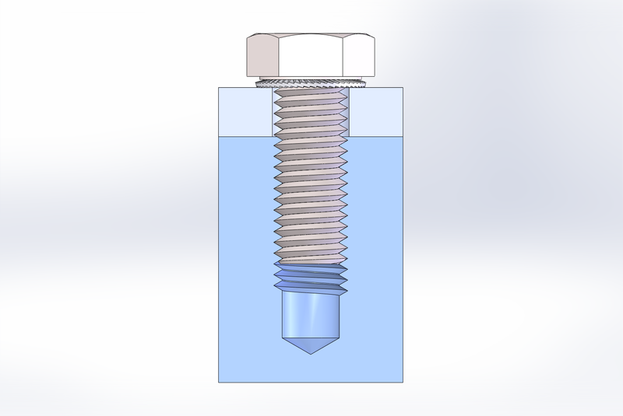

* **Adhesive bonding**

It is not resistant against tensile stress.

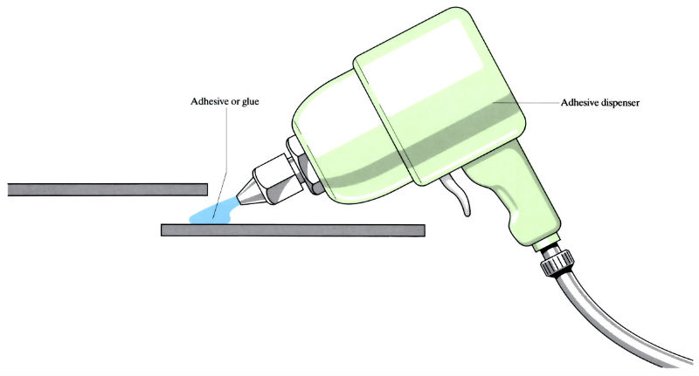

* **Riveting**

Riveting has some common functions with bolting, screwing, but is not based on friction. It is a stable connection used in aerospace technology (can be seen on planes’ wings). It is resistant to vibrations unlike bolts. It is a form connection because you deform the head of the rivet.

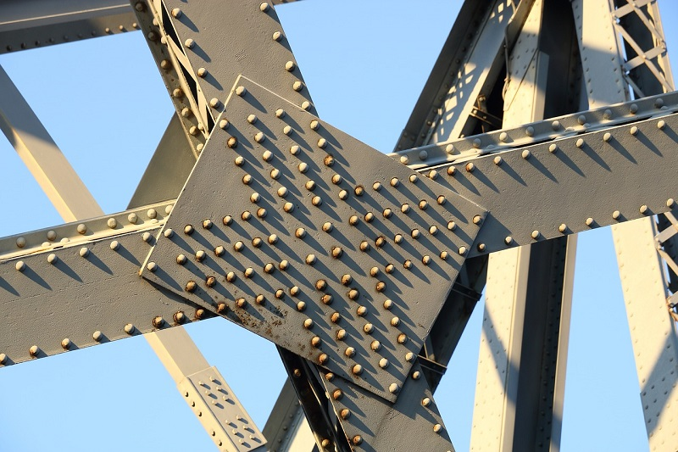

Riveting is a process that may be used to join parts together by way of a metal part called a rivet. The rivet acts to join the parts through adjacent surfaces. A straight metal piece is connected through the parts. Then both ends are formed over the connection, joining the parts securely.

* **Soldering and Brazing**

The components of the work piece are not melted to be joined, just the filler material that acts like glue.

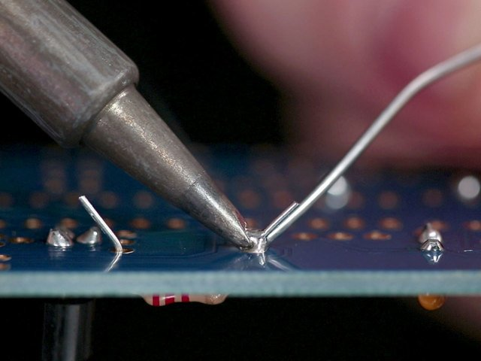

Filler material is needed, so weaker connection than welding but less energy needed and more precise. Also, materials do not need to be as similar as in welding.

You can braze with a torch, in a furnace, by induction, etc.

Soldering works at the same principle, but you work on even lower temperature by switching the filler material.

* **Welding (spoqvane)**

Here, the pieces you want to join are melted, a filler material is optional.

There are different technologies of welding which influence the cross-section of the seam (spoikata).  
The faster the material burns and solidifies, the smaller the seam, but it is also much more expensive.   
  
 Some materials have better or worse weldability (like machinability in milling and turning). Carbon steel is excellent for welding and somewhat almost all other steels. Aluminum is not easily weldable.

The weld quality is really important because many things can go wrong (porosity, surface damage, cracks, residual stress, distortion when the work piece cools). So, it is really difficult to create a geometrically accurate component.

***Types of welding***

Gas welding is typically done with a very high temperature (more than 3000 degrees Celsius), no electricity is needed- only gas. Different gas mixtures, create different flames.

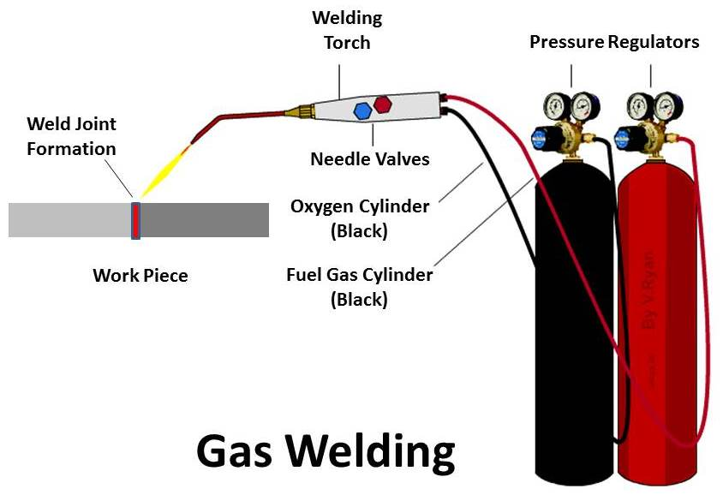

In arc welding, we are using electricity to melt material. The electrode burning the work piece can be either consumable or non-consumable.  
If it is consumable, the electrode and the wire are the filler and burn to create the seam. They are enveloped in a protective metal insert gas (MIG).  
When it is non-consumable, it is mostly made of tungsten that does not melt, the filler is applied separately.

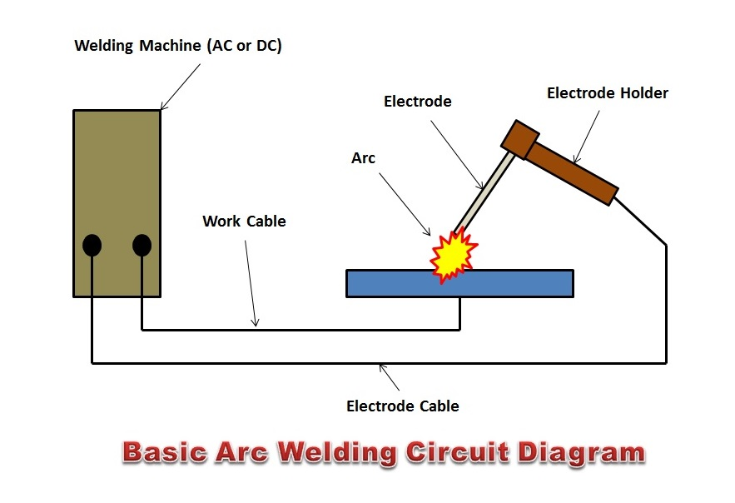

In resistance spot welding, called like this because it joins in a spot, components are pressed together, current is put through them which melts and joins them. No filler material is, thus, needed.

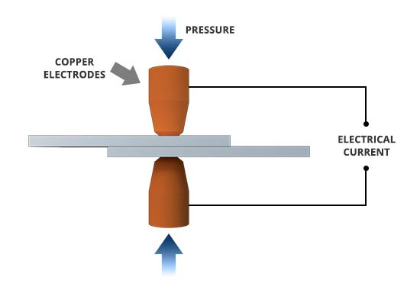

There is also resistance seam welding, called like this because it creates a seam. Here, the electrodes are wheels that are rolled together and pressed against each other. It is used in automotive industry to connect sheet metals.

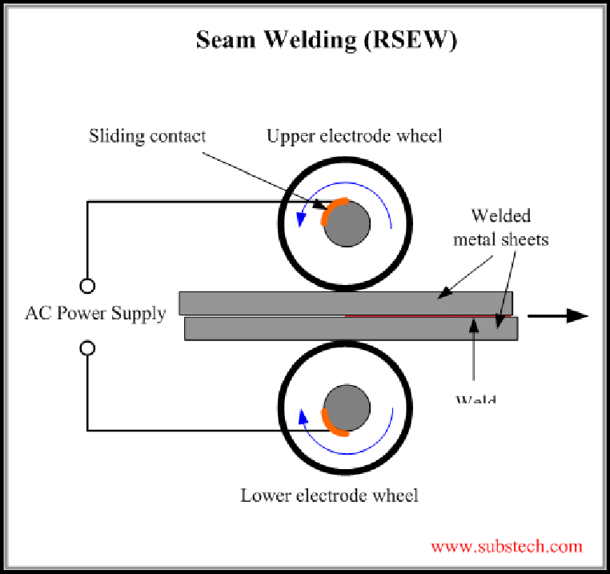

* **Diffusion bonding**

Diffusion (mass transport between two pieces in contact, they share particles) of material at half of the temperature of the melting point forms joint between two pieces through plastic deformation.

Suitable for volatile materials such as beryllium, titanium, etc.  
  
 Very slow, but highly dissimilar materials can be bonded unlike welding. There is no change in material properties, the quality if the bond is very high.

* **Adhesive bonding (gluing)**

If you know which glue has been used to make the joint, you can melt it away to separate the pieces without damaging them.

With a glued connection, you do not see bolts and rivets. Pressure is distributed on whole glued area, so good for big surfaces.

Naturally, there are many different types of glue. The stronger the glue, the harder to use.

This process can be automated and is used more and more frequently.

**Coating**

You have something with no defined shape (could be a vapor) that can be deposited as a thin layer on a work piece called substrate.

Some coating techniques are physical vapor deposition (PVD), chemical vapor deposition (CVD), electroplating, spraying, etc.   
PVD and CVD are very popular, for example, in tool making. You can coat your tool to increase its life and/or feasible cutting parameters (= productivity). Coating is put mostly on the rake side (side next to chip) but can be also put on the lower side of the tool.   
It also makes dry cutting feasible in some cases. This means no use of lubricants, thus, no evaporation (= mist) which can be volatile for workers whom otherwise need to protect themselves, so lower resource consumption since no protection is needed.  
Some other applications are protection against corrosion (automobile industry, in place of using expensive materials, we use cheap ones and we coat them), sealing, adhesion, surface quality, optical appearance, reflection, etc.

In PVD (physical vapor diffusion), the metal is evaporated at high temperature in a vacuum and is deposited on the substrate. Coating of uniform thickness can be deposited.

In CVD (chemical vapor diffusion), deposited coating is bigger than in PVD, heating is also higher, it is used to coat with titanium nitride.

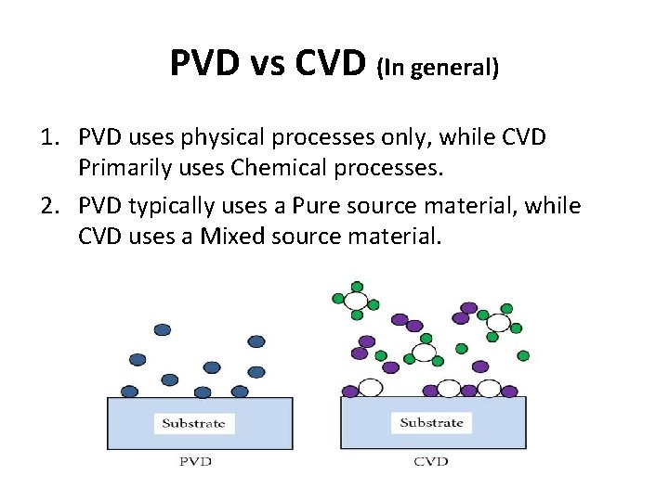

Both have to be done in a very clean environment because when you create vacuum every piece of dirt or grease will become a vapor and be an unwanted contamination of the coating and the machine.

**FORMULAS**

